Instructors: Please
- Always introduce the tasks of the lab first.
- For each code block, explain what you want to do first, then write code, and finally comment your code (so that others have time to catch up).

Lab 1 instructor:
- Explain the two datasets in detail. What they look like after you load the data. What are the columns and rows?
- Explain the three levels in detail.

In this lab, we will look at how to import data to Colab, then manipulate the data to find some basic statistics of the data—mean, median, min, max—and then filtering the data based on certain conditions.

The reason we are doing this is to both practice Python and to perform a process called data exploration which will always be the first step for any AI related project. Data exploration is essentially understanding what your data looks like, such as how it's distributed and what kinds of data you’re looking at.

First, I want to talk about how our lab will be structured. We will first have a lecture section where a presenter will be writing code on screen and everyone can follow along on their own device. Afterwards, we have an exercise section where you will work on a similar problem yourselves.

- Open google colab using colab.research.google.com but you don’t need to make a new notebook. Instead, you should copy the template notebook which you can find on the website (link here).
- Then, we need to go get the data from the website too. Link here (unzip the file download).
  - Use the iris.data file.
- Then, we need to upload it into Colab. A warning is going to pop up which we can ignore, but basically what it means is… Talk about the variables tab.
- Let’s take a look at the template code in the notebook. This code will be explained in Lecture 2 but for now trust me on the implementation. Let’s print out the sepal_lengths list to see what we have to work with.
print(sepal_lengths)
- We have the numbers, but there isn’t really any sense to them. We can simply use the sort function to sort the data from smallest to greatest:
sepal_lengths.sort()
- Now that we’ve isolated all the sepal lengths, we can find the mean, median, min, and max of the sepal lengths. I’m going to introduce the sum and len functions here. The sum function takes in a list as input and gives you the sum of all the values in the list. The len function also takes in a list as input but gives you the length of the list.
In order to find the mean, we can simply take the sum of the data, then divide it by the length of the data:
sepal_lengths_mean = sum(sepal_lengths) / len(sepal_lengths)
print('the mean is:',sepal_lengths_mean)
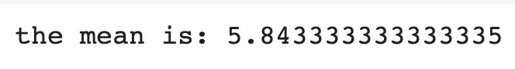
- The median is a bit more tricky. However, we can just use the length of the dataset and extract some specific values using it.
print(len(sepal_lengths))
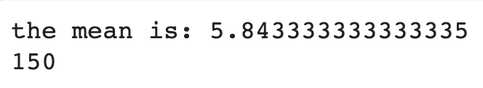
Keep in mind our sepal_lengths list is already sorted from lowest to greatest. So now we have the length, then we divide it by 2 to get that the middle two numbers are the 75th and 76th numbers. That means that the middle two indices are 74 and 75. We can then average those two values to get the median:
sepal_lengths_median = (sepal_lengths[74] + sepal_lengths[75])/2
print('the median is:', sepal_lengths_median)
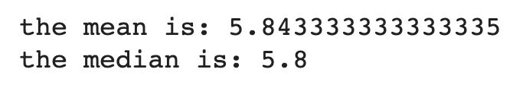
- The min and max are quite simple. There are built in min and max functions for Python. These do as you may expect. The min function gives you the smallest value in the list while the max function gives you the largest.
sepal_lengths_min = min(sepal_lengths)
print('the minimum is:', sepal_lengths_min)
sepal_lengths_max = max(sepal_lengths)
print('the maximum is:', sepal_lengths_max)
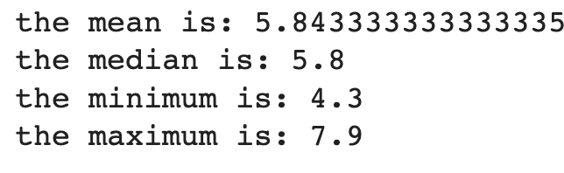
- Lastly, to experiment with filtering, we should try getting counting the amount of sepal lengths which are between 5 and 6
counter = 0

for length in sepal_lengths:
if length > 5 and length < 6:
counter = counter + 1

print(counter)

And now we have the mean, median, minimum, and maximum for the sepal lengths!

Now, try it on your own, with the fixed acidity in the wine quality dataset: https://archive.ics.uci.edu/ml/datasets/wine+quality, with nearly 5000 datapoints! Note: the data is formatted slightly differently, so be careful!

Find the link to the task on the website, there are 2 versions of the lab to choose from with different levels of additional scaffolding. Choose the one that you feel fits you the best. The answer key will be posted soon after.

Bonus Task:
Mean, median, min, and max are all important metrics to understand. There is one other thing we can do to our data. Scale all the values of the fixed acidity information to be between 0 and 1. (eg. min val -> 0 and max val -> 1)

